**ASSIGNMENT 10.2**

Implement the concept given in below blog link and share the complete steps along with screenshots.

LINK: - <https://acadgild.com/blog/loading-data-into-hbase-using-pig-scripts/>

Output:

Step 1:

We will download the dataset ‘AcadgildStudent’ as given in the assignment and store it in the acadgild home directory.

Step 2:

We will now copy the dataset ‘AcadgildStudent’ into hdfs which will further load into hbase.

Output:



Step 3:

We will include few jar files of Hbase into Pig Classpath.

Output:



Step 4:

We will now start the Hbase shell and create a table.

Output:

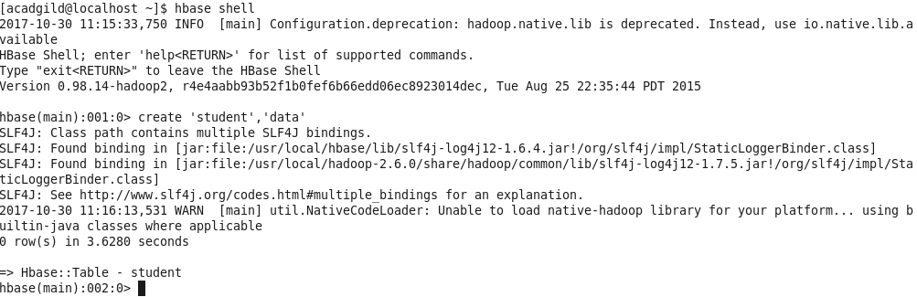

Step 5:

Now we are switching from Hbase to Pig grunt shell and load the data from Hdfs to Alias relation.

Output:



Step 6:

Now we can transfer the data inside HBase by STORE command.We need to ensure that we give the correct name for table name created inside HBase. Also the parameters should be kept in mind to avoid mistake.

Output:



Step 7:

The result can be displayed through scan command followed by table name inside quotes( ‘ ‘ ).

